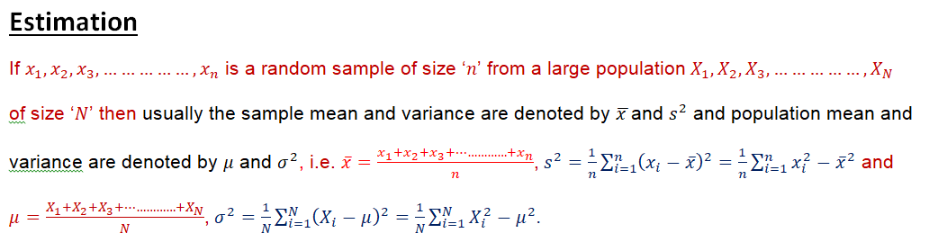
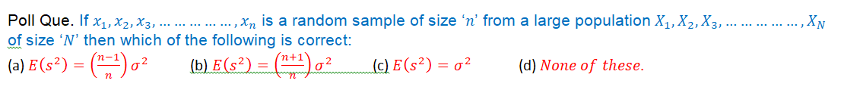
Poll Que. If $x_{1},x_{2},x_{3},……………,x_{n}$ is a random sample of size ‘$n$’ from a large population${ X}_{1},X_{2},X_{3},……………,X_{N}$
of size ‘$N$’ then which of the following is correct:
(a) $E\left(x_{i}\right)=μ^{2},E\left(\overline{x}\right)=μ$ (b) $E\left(x_{i}\right)=μ,E\left(\overline{x}\right)=μ$ (c) $E\left(x_{i}\right)=μ,E\left(\overline{x}\right)=μ^{2}$ (d) $None of these$.
Poll Que. If $x_{1},x_{2},x_{3},……………,x_{n}$ is a random sample of size ‘$n$’ from a large population${ X}_{1},X_{2},X_{3},……………,X_{N}$
of size ‘$N$’ then which of the following is correct:
(a) $V\left(x_{i}\right)=\frac{σ^{2}}{n},V\left(\overline{x}\right)=σ^{2}$ (b) $V\left(x_{i}\right)=σ^{2},V\left(\overline{x}\right)=σ^{2}$ (c) $V\left(x_{i}\right)=σ^{2},V\left(\overline{x}\right)=\frac{σ^{2}}{n}$ (d) $None of these$.
Poll Que. If $x_{1},x_{2},x_{3},……………,x_{n}$ is a random sample of size ‘$n$’ from a large population${ X}_{1},X_{2},X_{3},……………,X_{N}$
of size ‘$N$’ then which of the following is correct:
(a) $E\left(s^{2}\right)={\left(\frac{n-1}{n}\right)σ}^{2}$ (b) $E\left(s^{2}\right)={\left(\frac{n+1}{n}\right)σ}^{2}$ (c) $E\left(s^{2}\right)=σ^{2}$ (d) $None of these$.
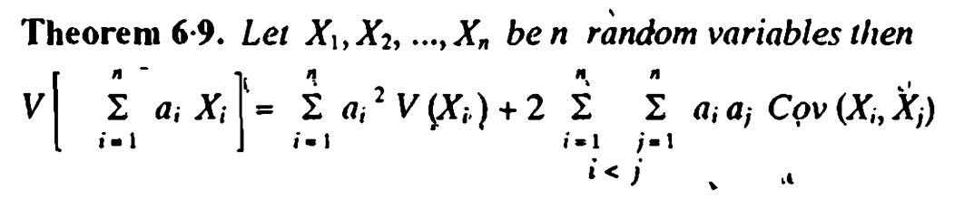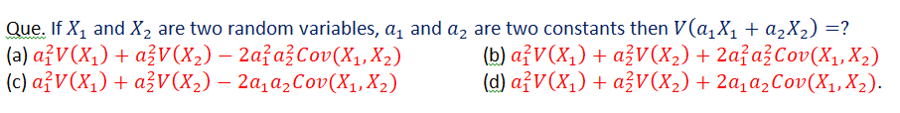

Remark: If $x_{1},x_{2},x_{3},……………,x_{n}$ is a random sample of size ‘$n$’ from a large population${ X}_{1},X_{2},X_{3},……………,X_{N}$of size ‘$N$’ then $E\left(x_{i}\right)=μ,E\left(\overline{x}\right)=μ$,$V\left(x_{i}\right)=σ^{2},$
$V\left(\overline{x}\right)=\frac{σ^{2}}{n}, E\left(s^{2}\right)={\left(\frac{n-1}{n}\right)σ}^{2}, E\left(S^{2}\right)=σ^{2}$ where $S^{2}=\frac{1}{n-1}\sum_{i=1}^{n}{{\left(x_{i}-\overline{x}\right)}^{2}.}$

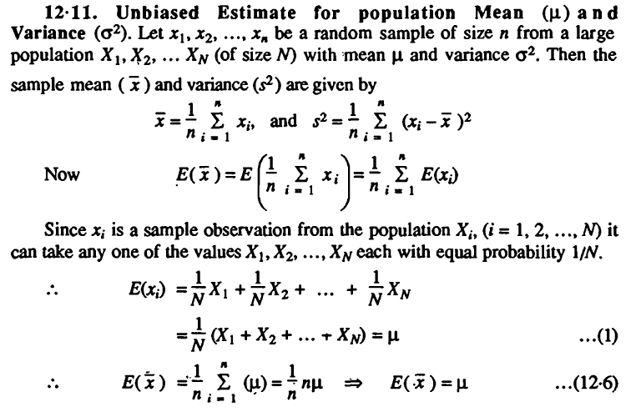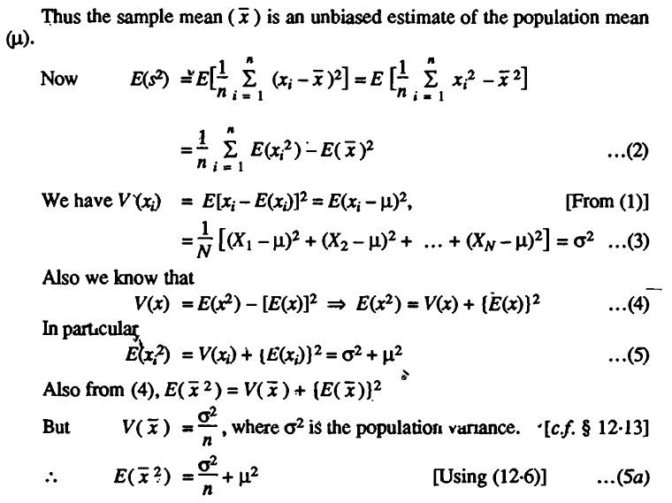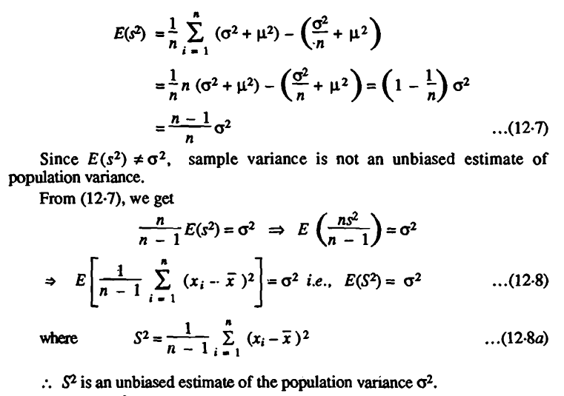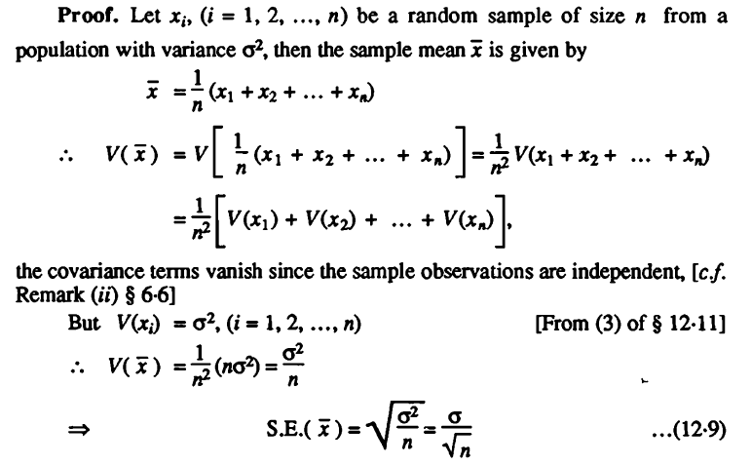

Characteristics of Estimators. The following are some of the criteria that should be satisfied by a good estimator.
(i) Unbiasedness (ii) Consistency (iii) Efficiency (iv) Sufficiency.

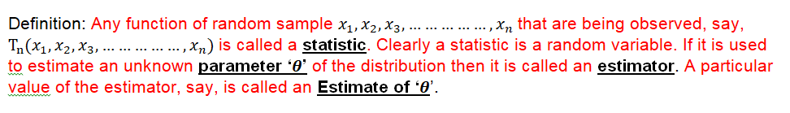

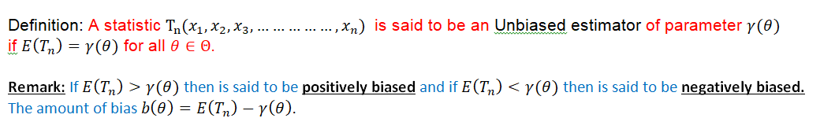
Q. An estimator $T_{n}$ is said to be an unbiased estimator of a parameter ‘$θ$’ if:

$E\left(T_{n}\right)=θ$ $T_{n}=θ Var.\left(T_{n}\right)=θ$ $E\left(T_{n}\right)=θ^{2}$

Q. If $x_{1},x_{2},x_{3},……………,x_{n}$ is a sample drawn from a population with population mean ‘$μ$’
then which of the following is correct:

(a) $E\left(x_{i}\right)=μ$ (b) $E\left(x_{i}\right)=μ^{2}$ (c) $E\left(x_{i}\right)=μ+1$ (d) $E\left(x_{i}^{2}\right)=μ$

Q. If $x_{1},x_{2},x_{3},……………,x_{n}$ is a sample drawn from a population with sample mean ‘$\overline{x}$’and
population mean ‘$μ$’ then which of the following is correct:

(a)$E\left({\overline{x}}^{2}\right)=μ$ (b) $E\left(\overline{x}\right)=μ^{2}$ (c) $E\left(\overline{x}\right)=\frac{μ}{n}$ (d)$E\left(\overline{x}\right)=μ$

Q. If $x_{1},x_{2},x_{3},……………,x_{n}$ is a sample drawn from a population with population variance ‘$σ^{2}$’ and
population mean ‘$μ$’ then which of the following is correct:

(a) $V\left(x_{i}\right)=σ^{2}$ (b) $V\left(x_{i}^{2}\right)=σ^{2}$ (c) $V\left(x_{i}\right)=μ$ (d) $V\left(x_{i}\right)=μ^{2}$

Q. If $x_{1},x_{2},x_{3},……………,x_{n}$ is a sample drawn from a population with sample mean ‘$\overline{x}$’,
population variance ‘$σ^{2}$’, population mean ‘$μ$’ then which of the following is correct:

$Var\left(\overline{x}\right)=\frac{σ^{2}}{n}$ $Var\left(\overline{\frac{x}{n}}\right)=\frac{σ^{2}}{n}$ $Var\left(\overline{x}\right)=\frac{μ^{2}}{n}$ $Var\left(\overline{x}\right)=σ^{2}$

Q. If ‘$s^{2}$’ is the sample variance of a sample $x_{1},x_{2},x_{3},……………,x_{n}$ drawn from a population
with population variance ‘$σ^{2}$’ then which of the following is correct:

(a) $E\left(s^{2}\right)={\left(\frac{n-1}{n}\right)σ}^{2}$ (b) $E\left(s^{2}\right)={\left(\frac{n+1}{n}\right)σ}^{2}$ (c) $E\left(s^{2}\right)=σ^{2}$ (d) $E\left(s^{2}\right)=\frac{σ^{2}}{n}$
Q. If $E\left(T\right)=θ$ and $V\left(T\right)>0$then which of the following is incorrect?

(a) $T^{2}$ is biased estimator of $θ^{2}$ (b) $T^{2}$ is unbiased estimator of $θ^{2}$ (c)$E\left(T^{2}\right)=θ^{2}+Var(T)$ (d) $E\left(T^{2}\right)≠θ^{2}$ a

Q. If ‘$\overline{x}$’ is the sample mean of a sample $x_{1},x_{2},x_{3},……………,x_{n}$ drawn from population with
population mean ‘$μ$’ and population variance '$σ^{2}$' then which of the following is correct:

$E({\overline{x}}^{2})=\left(\frac{σ^{2}}{n}\right)+μ^{2}$ $E({\overline{x}}^{2})=\left(\frac{σ^{2}}{n}\right)+μ$ $E({\overline{x}}^{2})=\left(\frac{σ^{2}}{n}\right)+\frac{μ^{2}}{n}$ $E({\overline{x}}^{2})=\left(\frac{σ^{2}}{n}\right)$

Q. If ‘m’ is the sample mean of a sample x₁,x₂,.....x_{n}, drawn from a Normal population with population mean ‘M’ and population variance 'V' then which of the following is correct:
E(m²)=(V/n)+M²

Q. If $x_{1},x_{2},x_{3},……………,x_{n}$ is a random sample of size ‘$n$’ from a Normal population with
population mean ‘$μ$’ and standard deviation '$3$' then $t=\frac{1}{n}\sum_{i=1}^{n}{x_{i}^{2}}$ is an unbiased estimator of:

(a) $3+μ$ (b) $9+μ^{2}$ (c) $3+μ^{2}$ (d) $9+μ$
Q. If $x_{1},x_{2},x_{3},……………,x_{n}$ is a random sample of size ‘$n$’ from a Normal population with population
mean ‘$μ$’ and population standard deviation '$3$' then $t=\frac{1}{n^{2}}\sum_{i=1}^{n}{x_{i}^{2}}$ is an unbiased estimator of:
(a) $3+μ$ (b) $\frac{9+μ^{2}}{n}$ (c) $3+μ^{2}$ (d) $9+μ^{2}$
Q. A sequence of estimators $\{T_{n}\}$ where n=1,2,3,......... is a consistent estimator of a parameter ‘$θ$’ if:

(a) $E\left(T_{n}\right)→θ, V\left(T_{n}\right)→0$ as $n→ ∞$ (b) $E\left(T_{n}\right)→0, V\left(T_{n}\right)→0$ as $n→ ∞$

(c) $E\left(T_{n}\right)→θ, V\left(T_{n}\right)→θ^{2}$ as $n→ ∞$ (d) $E\left(T_{n}\right)→0, V\left(T_{n}\right)→θ$ as $n→ ∞$

Q. Which of the following is the sufficient estimate of the parameter ‘$α$’ of a population having density
function:$αx^{α-1}, 0<x<1, α>0$ when a sample of $x_{1},x_{2},x_{3},……………,x_{n}$ is drawn from the population?
(a) $\sum_{i=1}^{n}{x_{i}^{2}}$ (b) $\sum_{i=1}^{n}{x_{i}}$ (c) $\overline{x}$ (d) $\prod_{i=1}^{n}{x_{i}}$.
Q. If $x_{1},x_{2},x_{3},……………,x_{n}$ is a sample drawn from a population with density function $f(x,α)$ then the
Likelihood function ‘$L$’ is given by:

$\prod_{i=1}^{n}{{f(x}_{i},α)}$ $\sum_{i=1}^{n}{{f(x}_{i},α)}$ ${f(x}_{1},α)-{f(x}_{2},α)-{f(x}_{3},α)-……………-{f(x}_{n},α)$ ${f(x}_{1},α)-{f(x}_{2},α)+{f(x}_{3},α)-……………+{\left(-1\right)}^{n+1}{f(x}_{n},α)$

Q. Which of the following is the maximum likelihood estimate of the parameter ‘$α$’ of a population having
density function:$\frac{3}{α^{3}}\left(α-x\right), 0<x<α$ when a sample of unit size is drawn from the population? (Here ‘$x$’ is the sample value).
(a) $2x$ (b) $x$ (c) $\frac{x}{2}$ (d) $None of these$.

Definition: Any function of random sample $x_{1},x_{2},x_{3},……………,x_{n}$that are being observed, say,
${T_{n}(x}_{1},x_{2},x_{3},……………,x_{n})$is called a statistic. Clearly a statistic is a random variable. If it is used
to estimate an unknown parameter ‘$θ$’ of the distribution then it is called an estimator. A particular
value of the estimator, say, is called an Estimate of ‘$θ$’.

Definition: A statistic${T_{n}(x}_{1},x_{2},x_{3},……………,x_{n})$ is said to be an Unbiased estimator of parameter $γ(θ)$
if $E\left(T_{n}\right)=γ(θ)$ for all $θ∈Θ.$

Remark: If $E\left(T_{n}\right)>γ(θ)$ then is said to be positively biased and if $E\left(T_{n}\right)<γ(θ)$ then is said to be negatively biased.
The amount of bias $b\left(θ\right)=E\left(T_{n}\right)-γ\left(θ\right).$

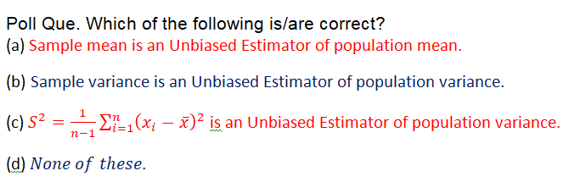
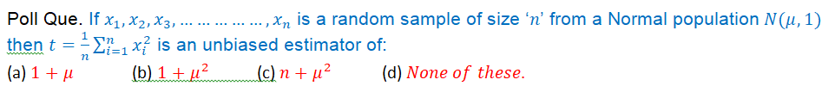

Poll Que. Which of the following is/are correct?
(a) Sample mean is an Unbiased Estimator of population mean.
(b) Sample variance is an Unbiased Estimator of population variance.
(c) $S^{2}=\frac{1}{n-1}\sum_{i=1}^{n}{{\left(x_{i}-\overline{x}\right)}^{2} }$is an Unbiased Estimator of population variance.
(d) $None of these$.
Poll Que. If $x_{1},x_{2},x_{3},……………,x_{n}$ is a random sample of size ‘$n$’ from a Normal population$N(μ,1)$
then $t=\frac{1}{n}\sum_{i=1}^{n}{x_{i}^{2}}$ is an unbiased estimator of:
(a) $1+μ$ (b) $1+μ^{2}$ (c) $n+μ^{2}$ (d) $None of these$.
Remark: If ‘$T$’ is an unbiased estimator of ‘$θ$’ then ‘$T^{2}$’ is a biased estimator of ‘$θ^{2}$’.

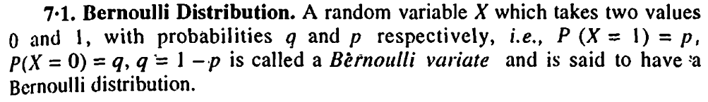
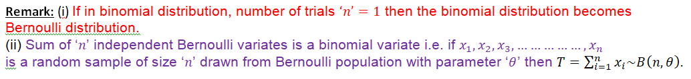
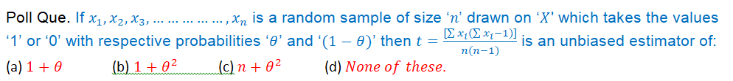
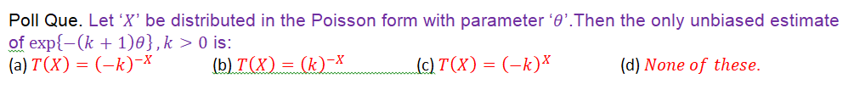
Remark: (i) If in binomial distribution, number of trials $‘n’=1$ then the binomial distribution becomes
Bernoulli distribution.
(ii) Sum of ‘$n$’ independent Bernoulli variates is a binomial variate i.e. if $x_{1},x_{2},x_{3},……………,x_{n}$
is a random sample of size ‘$n$’ drawn from Bernoulli population with parameter ‘$θ$’ then $T=\sum_{i=1}^{n}{x_{i}\sim B\left(n,θ\right).}$

Poll Que. If $x_{1},x_{2},x_{3},……………,x_{n}$ is a random sample of size ‘$n$’ drawn on ‘$X$' which takes the values
‘1’ or ‘0’ with respective probabilities ‘$θ$’ and ‘$(1-θ)$’ then $t=\frac{[\sum{x_{i}}(\sum{x_{i}-1})]}{n(n-1)}$ is an unbiased estimator of:
(a) $1+θ$ (b) $1+θ^{2}$ (c) $n+θ^{2}$ (d) $None of these$.
Poll Que. Let ‘$X$’ be distributed in the Poisson form with parameter ‘$θ$’.Then the only unbiased estimate of $\exp\left\{-\left(k+1\right)θ\right\}, k>0$ is:
(a) ${T\left(X\right)=\left(-k\right)}^{-X}$ (b) ${T\left(X\right)=\left(k\right)}^{-X}$ (c) ${T\left(X\right)=\left(-k\right)}^{X}$ (d) $None of these$.

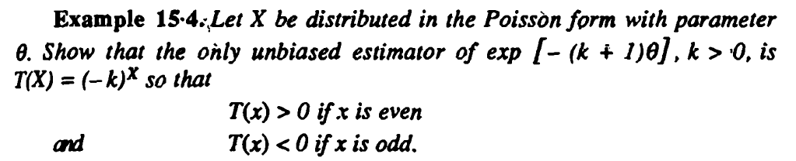
Poll Que. Let ‘$X$’ be distributed in the Poisson form with parameter ‘$θ$’ and $s^{2}=\frac{1}{n}∑{\left(x_{i}-\overline{x}\right)}^{2}.$
Then $(\overline{x}-s^{2})$ is an unbiased estimate of:
(a) $θ$ (b) $\frac{θ}{n}$ (c) $\frac{θ^{2}}{n}$ (d) $None of these$.

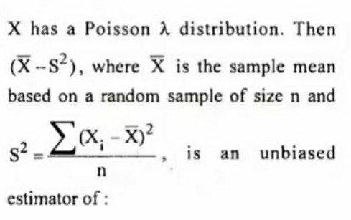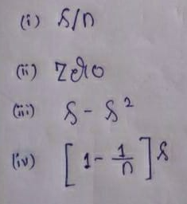

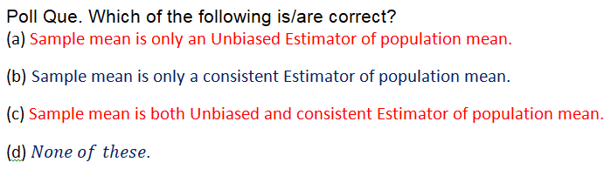

Poll Que. Which of the following is/are correct?
(a) Sample mean is only an Unbiased Estimator of population mean.
(b) Sample mean is only a consistent Estimator of population mean.
(c) Sample mean is both Unbiased and consistent Estimator of population mean.
(d) $None of these$.

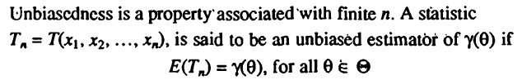

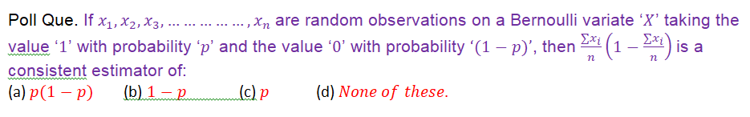
Poll Que. If $x_{1},x_{2},x_{3},……………,x_{n}$are random observations on a Bernoulli variate ‘$X$’ taking the
value ‘$1$’ with probability ‘$p$’ and the value ‘$0$’ with probability $‘(1-p)’$, then $\frac{∑x_{i}}{n}\left(1-\frac{∑x_{i}}{n}\right)$is a
consistent estimator of:
(a) $p(1-p)$ (b) $1-p$ (c) $p$ (d) $None of these$.

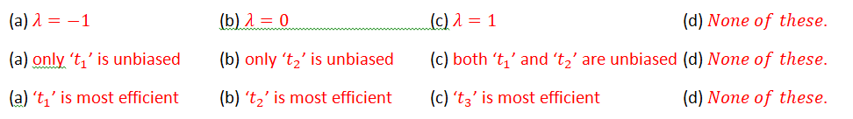
(a) $λ=-1$ (b) $λ=0$ (c) $λ=1$ (d) $None of these$.
(a) only ‘$t_{1}$’ is unbiased (b) only ‘$t_{2}$’ is unbiased (c) both ‘$t_{1}$’ and ‘$t_{2}$’ are unbiased (d) $None of these$.
(a) ‘$t_{1}$’ is most efficient (b) ‘$t_{2}$’ is most efficient (c) ‘$t_{3}$’ is most efficient (d) $None of these$.
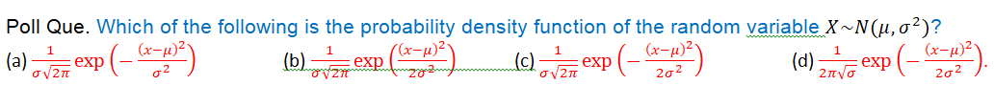
Poll Que. Which of the following is the probability density function of the random variable$X\sim N(μ,σ^{2})$?
(a) $\frac{1}{σ\sqrt{2π}}\exp\left(-\frac{{\left(x-μ\right)}^{2}}{σ^{2}}\right)$ (b) $\frac{1}{σ\sqrt{2π}}\exp\left(\frac{{\left(x-μ\right)}^{2}}{2σ^{2}}\right)$ (c) $\frac{1}{σ\sqrt{2π}}\exp\left(-\frac{{\left(x-μ\right)}^{2}}{2σ^{2}}\right)$ (d) $\frac{1}{2π\sqrt{σ}}\exp\left(-\frac{{\left(x-μ\right)}^{2}}{2σ^{2}}\right)$.
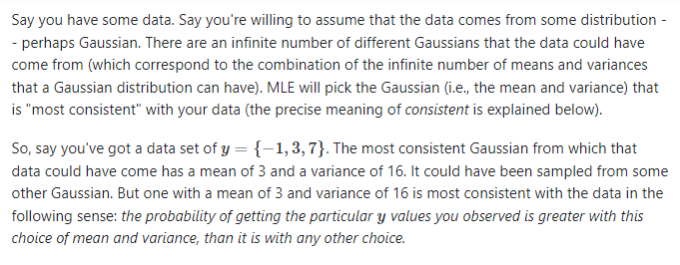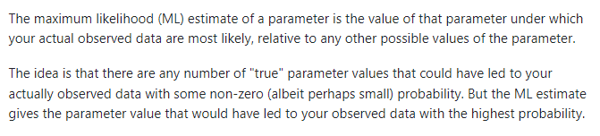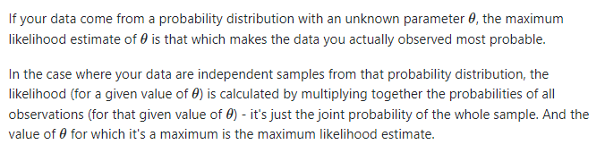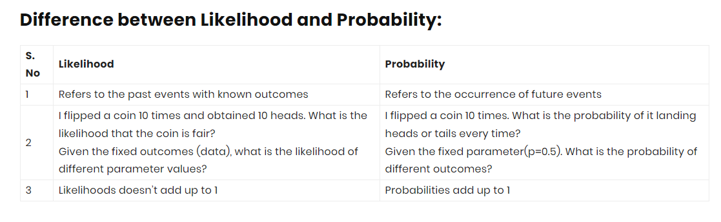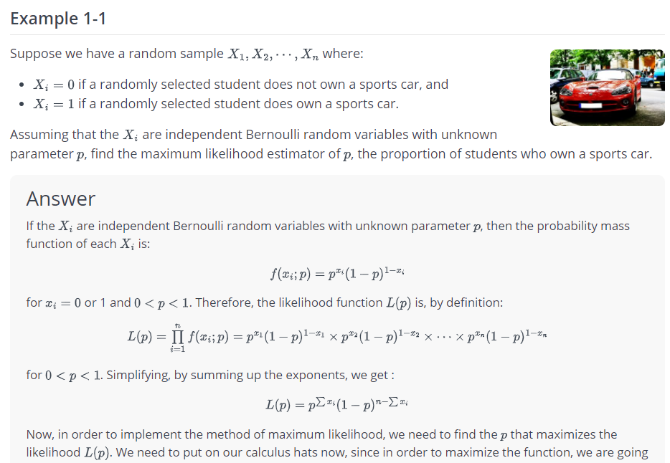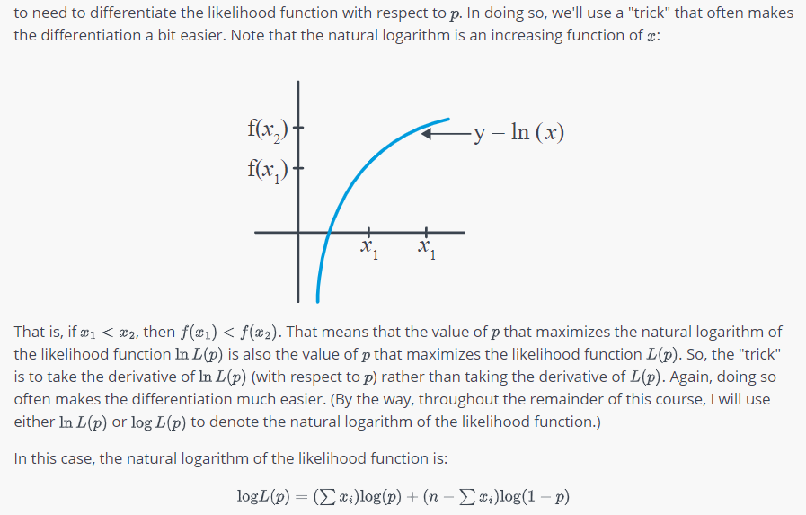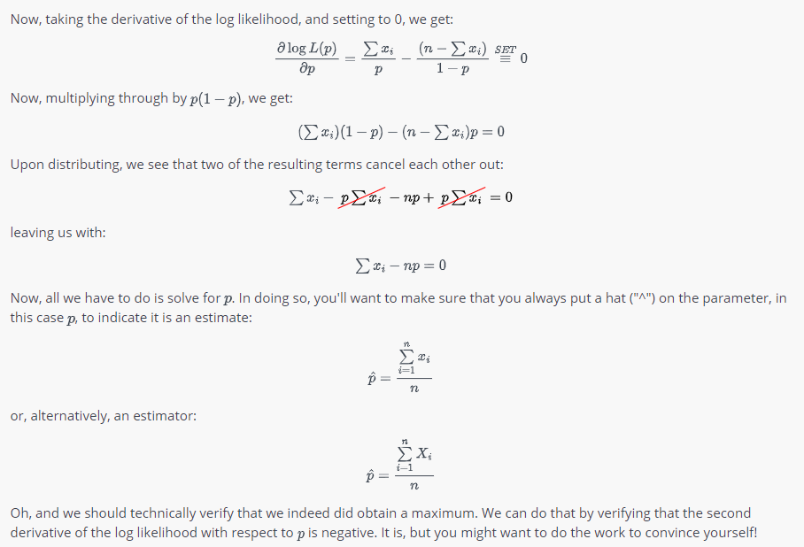
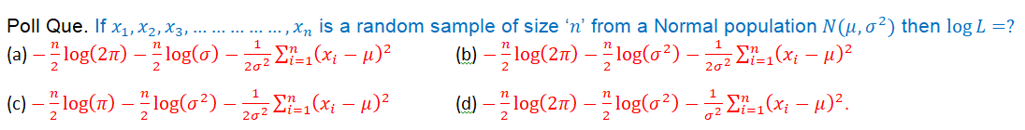
Poll Que. If $x_{1},x_{2},x_{3},……………,x_{n}$ is a random sample of size ‘$n$’ from a Normal population$N(μ,σ^{2})$ then $\log{L}=?$
(a) $-\frac{n}{2}\log\left(2π\right)-\frac{n}{2}\log\left(σ\right)-\frac{1}{2σ^{2}}\sum_{i=1}^{n}{{\left(x_{i}-μ\right)}^{2}}$ (b) $-\frac{n}{2}\log\left(2π\right)-\frac{n}{2}\log\left(σ^{2}\right)-\frac{1}{2σ^{2}}\sum_{i=1}^{n}{{\left(x_{i}-μ\right)}^{2}}$
(c) $-\frac{n}{2}\log\left(π\right)-\frac{n}{2}\log\left(σ^{2}\right)-\frac{1}{2σ^{2}}\sum_{i=1}^{n}{{\left(x_{i}-μ\right)}^{2}}$ (d) $-\frac{n}{2}\log\left(2π\right)-\frac{n}{2}\log\left(σ^{2}\right)-\frac{1}{σ^{2}}\sum_{i=1}^{n}{{\left(x_{i}-μ\right)}^{2}}$.
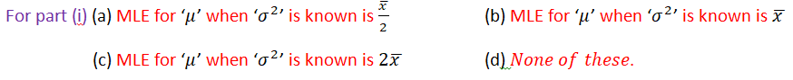
For part (i) (a) MLE for ‘$μ$’ when ‘$σ^{2}$’ is known is $\frac{\overline{x }}{2}$ (b) MLE for ‘$μ$’ when ‘$σ^{2}$’ is known is $\overline{x }$
(c) MLE for ‘$μ$’ when ‘$σ^{2}$’ is known is $2\overline{x }$ (d) $None of these$.
For part (ii) (a) MLE for ‘$σ^{2}$’ when ‘$μ$’ is known is $\frac{1}{n}\sum_{i=1}^{n}{{\left(x_{i}-\overline{x }\right)}^{2}}$ (b) MLE for ‘$σ^{2}$’ when ‘$μ$’ is known is $\frac{1}{n-1}\sum_{i=1}^{n}{{\left(x_{i}-μ\right)}^{2}}$
(c) MLE for ‘$σ^{2}$’ when ‘$μ$’ is known is $\frac{1}{n}\sum_{i=1}^{n}{{\left(x_{i}-μ\right)}^{2}}$ (d) $None of these$.
For part (iii) (a) MLE for ‘$μ$’ and ‘$σ^{2}$’ are $\overline{x }$and $s^{2}$respectively (b) MLE for ‘$μ$’ and ‘$σ^{2}$’ are $\overline{x }$and $\frac{1}{n}\sum_{i=1}^{n}{{\left(x_{i}-μ\right)}^{2}}$ respectively (c) MLE for ‘$μ$’ and ‘$σ^{2}$’ are $\overline{x }$and $\frac{1}{n-1}\sum_{i=1}^{n}{{\left(x_{i}-\overline{x}\right)}^{2}}$ respectively (d) $None of these$.
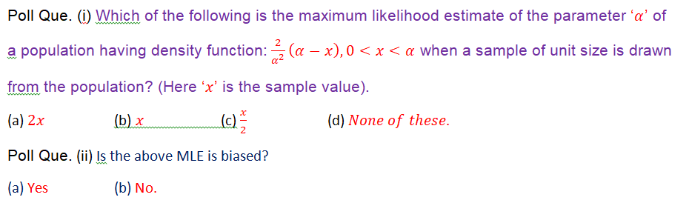
Poll Que. (i) Which of the following is the maximum likelihood estimate of the parameter ‘$α$’ of
a population having density function:$\frac{2}{α^{2}}\left(α-x\right), 0<x<α$ when a sample of unit size is drawn
from the population? (Here ‘$x$’ is the sample value).
(a) $2x$ (b) $x$ (c) $\frac{x}{2}$ (d) $None of these$.
Poll Que. (ii) Is the above MLE is biased?
(a) Yes (b) No.

